2018 App Team Projects / Tasks:

# Staff Center

Integrating scatted web application to the staff center, virtually as the starting point for all homegrown applications used by housing employees including student staff. The following applications are currently integrated.

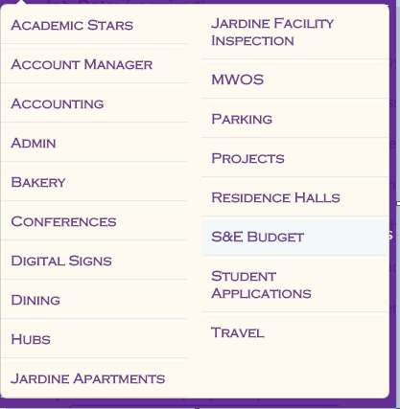

Future additions to Staff Center:

1. MWOS > Facilities Projects – (assigned to– Zayin )
2. Admin > Travel Request/ Approval form. (Under construction) (assigned to -Dishan)
3. Jardine Inspection - ECI ( Currently a separate application) (assigned to –Brandon)
4. Dining >Meal Cards. ( Currently a separate application) (assigned to- Will)
5. Streamline account request form with workflow. (assigned to- Gamage)
6. Residence hall /Jardine Check-IN and Check-out residents. (assigned to- Gamage)
7. Early Check-in verification. ( used in the during two weeks prior to fall start)
8. Admin> HR Exit Form work flow (assigned- to Gamage)
9. Admin>Position request from (assigned to Dishan)
10. DA 110 process (not assigned yet)
11. HDS policies and procedures (not assigned yet)
12. ID badge request form –can be integrated to account request
13. Buy out functionality.

In addition to apps listed above Apps team will work on multiple changes/enhancements in the existing applications in the Staff center, not limited to the above list.

# HMS –scope/maintenance

Housing and Dining maintains multiple housing apps in residentportal.

1. Residence Hall Fall Application.
2. Residence Hall Spring Application
3. Residence Hall Summer application.
4. Jardine Application
5. Jardine Off Campus Meal Plan
6. Residence hall Room selection
7. Jardine Room selection.
8. Offline housing application. ( limited access)

We have to apply changes to these systems based on the decision we make every year.

Constantly make improvements to the resident portal, based on the feedback we get from the students and the staff.

Housing billing is automated as of now. Charges posted in HMS goes to KSIS on the next business day or on the assigned poste date.

Every weekday and Saturday, KSIS send the payment, to the HMS database automatically.

IT and Cashiers work closely to verify the accuracy of the billing process and reconciliation.

Jardine monthly charges post to KSIS on 11th of the month. Semester charges post of 7/11 and 12/11.

ResDESK Application

CS GOLD/PCS/HMS/ integration

ID CONNECT/PCS integration